Product Inventory Management System
Backend Project Report
Node.js | Express.js | MongoDB
Student Project Documentation
Date | 09-03-2026
Team ID | 69a6b589c3309e5746ec38b0
Project Name | Product Inventory Management System
PROJECT OVERVIEW
The Product Inventory Management System is a backend-focused web application developed using Node.js, Express.js, and MongoDB, designed to provide a secure and scalable solution for managing product data through RESTful APIs. The system enables users to create accounts, log in securely, and access protected routes using JWT-based authentication, ensuring that only authorized users can perform operations. It supports complete CRUD functionality, allowing users to add new products, view their inventory, update product details such as price or quantity, and delete items when needed.

Abstract
The Product Inventory Management System is a backend web application developed using Node.js, Express.js, and MongoDB. The system allows users to register, log in securely using JWT authentication, and manage product inventory through RESTful APIs. The application supports full CRUD operations, allowing users to create, read, update, and delete product records. Each product is associated with a specific user to ensure secure and private data access.
The Product Inventory Management System is a backend web application developed using Node.js, Express.js, and MongoDB. The system allows users to register, log in securely using JWT authentication, and manage product inventory through RESTful APIs. The application supports full CRUD operations, allowing users to create, read, update, and delete product records. Each product is associated with a specific user to ensure secure and private data access.
The Product Inventory Management System is a backend web application developed using Node.js, Express.js, and MongoDB. The system allows users to register, log in securely using JWT authentication, and manage product inventory through RESTful APIs. The application supports full CRUD operations, allowing users to create, read, update, and delete product records. Each product is associated with a specific user to ensure secure and private data access.
The Product Inventory Management System is a backend web application developed using Node.js, Express.js, and MongoDB. The system allows users to register, log in securely using JWT authentication, and manage product inventory through RESTful APIs. The application supports full CRUD operations, allowing users to create, read, update, and delete product records. Each product is associated with a specific user to ensure secure and private data access.
The Product Inventory Management System is a backend web application developed using Node.js, Express.js, and MongoDB. The system allows users to register, log in securely using JWT authentication, and manage product inventory through RESTful APIs. The application supports full CRUD operations, allowing users to create, read, update, and delete product records. Each product is associated with a specific user to ensure secure and private data access.
The Product Inventory Management System is a backend web application developed using Node.js, Express.js, and MongoDB. The system allows users to register, log in securely using JWT authentication, and manage product inventory through RESTful APIs. The application supports full CRUD operations, allowing users to create, read, update, and delete product records. Each product is associated with a specific user to ensure secure and private data access.

1. Introduction
Inventory management is an essential requirement for businesses that deal with physical goods. Traditional manual inventory systems are time-consuming and prone to human errors. Modern web applications provide automated solutions that improve accuracy, efficiency, and accessibility. This project demonstrates the development of a backend inventory system using modern JavaScript technologies.
Inventory management is an essential requirement for businesses that deal with physical goods. Traditional manual inventory systems are time-consuming and prone to human errors. Modern web applications provide automated solutions that improve accuracy, efficiency, and accessibility. This project demonstrates the development of a backend inventory system using modern JavaScript technologies.
Inventory management is an essential requirement for businesses that deal with physical goods. Traditional manual inventory systems are time-consuming and prone to human errors. Modern web applications provide automated solutions that improve accuracy, efficiency, and accessibility. This project demonstrates the development of a backend inventory system using modern JavaScript technologies.
Inventory management is an essential requirement for businesses that deal with physical goods. Traditional manual inventory systems are time-consuming and prone to human errors. Modern web applications provide automated solutions that improve accuracy, efficiency, and accessibility. This project demonstrates the development of a backend inventory system using modern JavaScript technologies.
Inventory management is an essential requirement for businesses that deal with physical goods. Traditional manual inventory systems are time-consuming and prone to human errors. Modern web applications provide automated solutions that improve accuracy, efficiency, and accessibility. This project demonstrates the development of a backend inventory system using modern JavaScript technologies.
Inventory management is an essential requirement for businesses that deal with physical goods. Traditional manual inventory systems are time-consuming and prone to human errors. Modern web applications provide automated solutions that improve accuracy, efficiency, and accessibility. This project demonstrates the development of a backend inventory system using modern JavaScript technologies.

2. Project Objectives
The primary objective of this project is to develop a secure backend application capable of managing product inventory. The system implements user authentication, secure API access, and efficient database operations. The application also demonstrates best practices in backend development including modular architecture, middleware usage, and REST API design.
The primary objective of this project is to develop a secure backend application capable of managing product inventory. The system implements user authentication, secure API access, and efficient database operations. The application also demonstrates best practices in backend development including modular architecture, middleware usage, and REST API design.
The primary objective of this project is to develop a secure backend application capable of managing product inventory. The system implements user authentication, secure API access, and efficient database operations. The application also demonstrates best practices in backend development including modular architecture, middleware usage, and REST API design.
The primary objective of this project is to develop a secure backend application capable of managing product inventory. The system implements user authentication, secure API access, and efficient database operations. The application also demonstrates best practices in backend development including modular architecture, middleware usage, and REST API design.
The primary objective of this project is to develop a secure backend application capable of managing product inventory. The system implements user authentication, secure API access, and efficient database operations. The application also demonstrates best practices in backend development including modular architecture, middleware usage, and REST API design.
The primary objective of this project is to develop a secure backend application capable of managing product inventory. The system implements user authentication, secure API access, and efficient database operations. The application also demonstrates best practices in backend development including modular architecture, middleware usage, and REST API design.

3. System Architecture
The system follows a three-tier backend architecture consisting of the presentation layer, application logic layer, and database layer. Node.js and Express.js handle API routing and business logic, while MongoDB stores application data. Mongoose is used as the Object Data Modeling (ODM) library to interact with the database.
The system follows a three-tier backend architecture consisting of the presentation layer, application logic layer, and database layer. Node.js and Express.js handle API routing and business logic, while MongoDB stores application data. Mongoose is used as the Object Data Modeling (ODM) library to interact with the database.
The system follows a three-tier backend architecture consisting of the presentation layer, application logic layer, and database layer. Node.js and Express.js handle API routing and business logic, while MongoDB stores application data. Mongoose is used as the Object Data Modeling (ODM) library to interact with the database.
The system follows a three-tier backend architecture consisting of the presentation layer, application logic layer, and database layer. Node.js and Express.js handle API routing and business logic, while MongoDB stores application data. Mongoose is used as the Object Data Modeling (ODM) library to interact with the database.
The system follows a three-tier backend architecture consisting of the presentation layer, application logic layer, and database layer. Node.js and Express.js handle API routing and business logic, while MongoDB stores application data. Mongoose is used as the Object Data Modeling (ODM) library to interact with the database.
The system follows a three-tier backend architecture consisting of the presentation layer, application logic layer, and database layer. Node.js and Express.js handle API routing and business logic, while MongoDB stores application data. Mongoose is used as the Object Data Modeling (ODM) library to interact with the database.

4. Technologies Used
The backend system is developed using Node.js and Express.js as the primary framework. MongoDB is used as the NoSQL database, while Mongoose provides schema modeling and database interaction. JWT (JSON Web Token) is used for authentication and bcrypt is used for secure password hashing.
The backend system is developed using Node.js and Express.js as the primary framework. MongoDB is used as the NoSQL database, while Mongoose provides schema modeling and database interaction. JWT (JSON Web Token) is used for authentication and bcrypt is used for secure password hashing.
The backend system is developed using Node.js and Express.js as the primary framework. MongoDB is used as the NoSQL database, while Mongoose provides schema modeling and database interaction. JWT (JSON Web Token) is used for authentication and bcrypt is used for secure password hashing.
The backend system is developed using Node.js and Express.js as the primary framework. MongoDB is used as the NoSQL database, while Mongoose provides schema modeling and database interaction. JWT (JSON Web Token) is used for authentication and bcrypt is used for secure password hashing.
The backend system is developed using Node.js and Express.js as the primary framework. MongoDB is used as the NoSQL database, while Mongoose provides schema modeling and database interaction. JWT (JSON Web Token) is used for authentication and bcrypt is used for secure password hashing.
The backend system is developed using Node.js and Express.js as the primary framework. MongoDB is used as the NoSQL database, while Mongoose provides schema modeling and database interaction. JWT (JSON Web Token) is used for authentication and bcrypt is used for secure password hashing.

5. Database Design
The database consists of two main collections: Users and Products. The Users collection stores authentication information such as name, email, and hashed password. The Products collection stores product information including name, price, quantity, description, and a reference to the user who created the product.
The database consists of two main collections: Users and Products. The Users collection stores authentication information such as name, email, and hashed password. The Products collection stores product information including name, price, quantity, description, and a reference to the user who created the product.
The database consists of two main collections: Users and Products. The Users collection stores authentication information such as name, email, and hashed password. The Products collection stores product information including name, price, quantity, description, and a reference to the user who created the product.
The database consists of two main collections: Users and Products. The Users collection stores authentication information such as name, email, and hashed password. The Products collection stores product information including name, price, quantity, description, and a reference to the user who created the product.
The database consists of two main collections: Users and Products. The Users collection stores authentication information such as name, email, and hashed password. The Products collection stores product information including name, price, quantity, description, and a reference to the user who created the product.
The database consists of two main collections: Users and Products. The Users collection stores authentication information such as name, email, and hashed password. The Products collection stores product information including name, price, quantity, description, and a reference to the user who created the product.

6. API Development
The backend exposes RESTful API endpoints for authentication and product management. Authentication APIs include register and login operations. Product APIs allow users to create, retrieve, update, and delete products. All product routes are protected using authentication middleware.
The backend exposes RESTful API endpoints for authentication and product management. Authentication APIs include register and login operations. Product APIs allow users to create, retrieve, update, and delete products. All product routes are protected using authentication middleware.
The backend exposes RESTful API endpoints for authentication and product management. Authentication APIs include register and login operations. Product APIs allow users to create, retrieve, update, and delete products. All product routes are protected using authentication middleware.
The backend exposes RESTful API endpoints for authentication and product management. Authentication APIs include register and login operations. Product APIs allow users to create, retrieve, update, and delete products. All product routes are protected using authentication middleware.
The backend exposes RESTful API endpoints for authentication and product management. Authentication APIs include register and login operations. Product APIs allow users to create, retrieve, update, and delete products. All product routes are protected using authentication middleware.
The backend exposes RESTful API endpoints for authentication and product management. Authentication APIs include register and login operations. Product APIs allow users to create, retrieve, update, and delete products. All product routes are protected using authentication middleware.

7. API Testing using Thunder Client
API testing is performed using Thunder Client inside Visual Studio Code. Each endpoint is tested individually to ensure proper functionality and response handling. Authorization headers are used to send JWT tokens for protected routes.
API testing is performed using Thunder Client inside Visual Studio Code. Each endpoint is tested individually to ensure proper functionality and response handling. Authorization headers are used to send JWT tokens for protected routes.
API testing is performed using Thunder Client inside Visual Studio Code. Each endpoint is tested individually to ensure proper functionality and response handling. Authorization headers are used to send JWT tokens for protected routes.
API testing is performed using Thunder Client inside Visual Studio Code. Each endpoint is tested individually to ensure proper functionality and response handling. Authorization headers are used to send JWT tokens for protected routes.
API testing is performed using Thunder Client inside Visual Studio Code. Each endpoint is tested individually to ensure proper functionality and response handling. Authorization headers are used to send JWT tokens for protected routes.
API testing is performed using Thunder Client inside Visual Studio Code. Each endpoint is tested individually to ensure proper functionality and response handling. Authorization headers are used to send JWT tokens for protected routes.

Create Product API
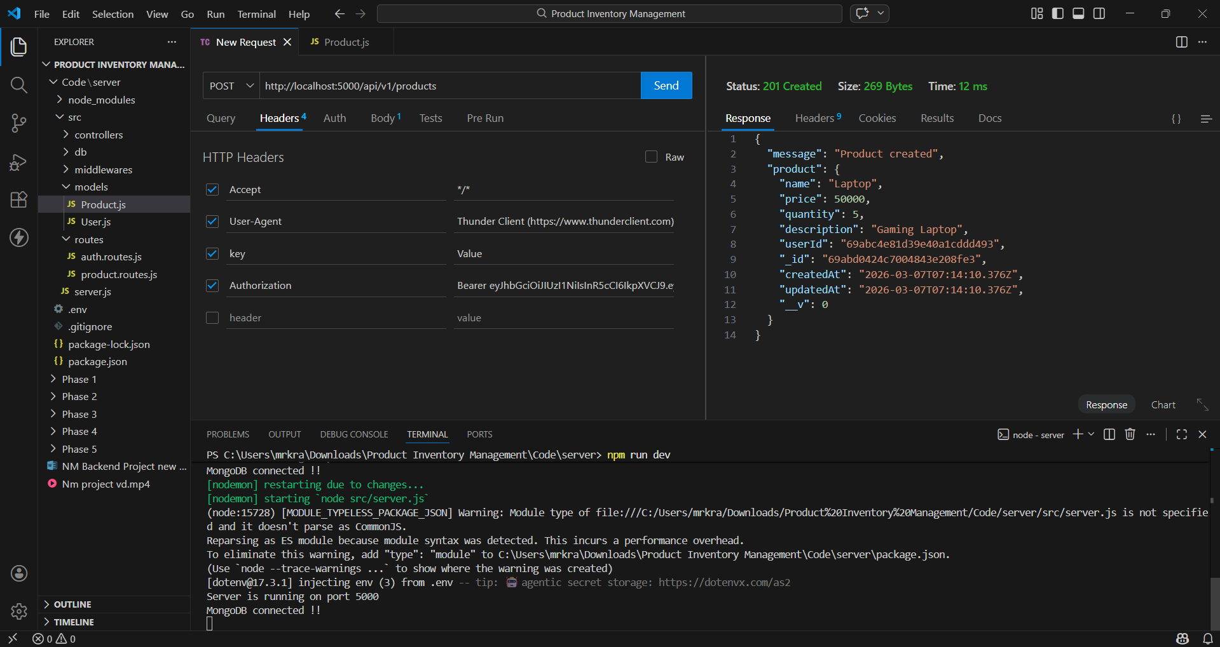

Update Product API
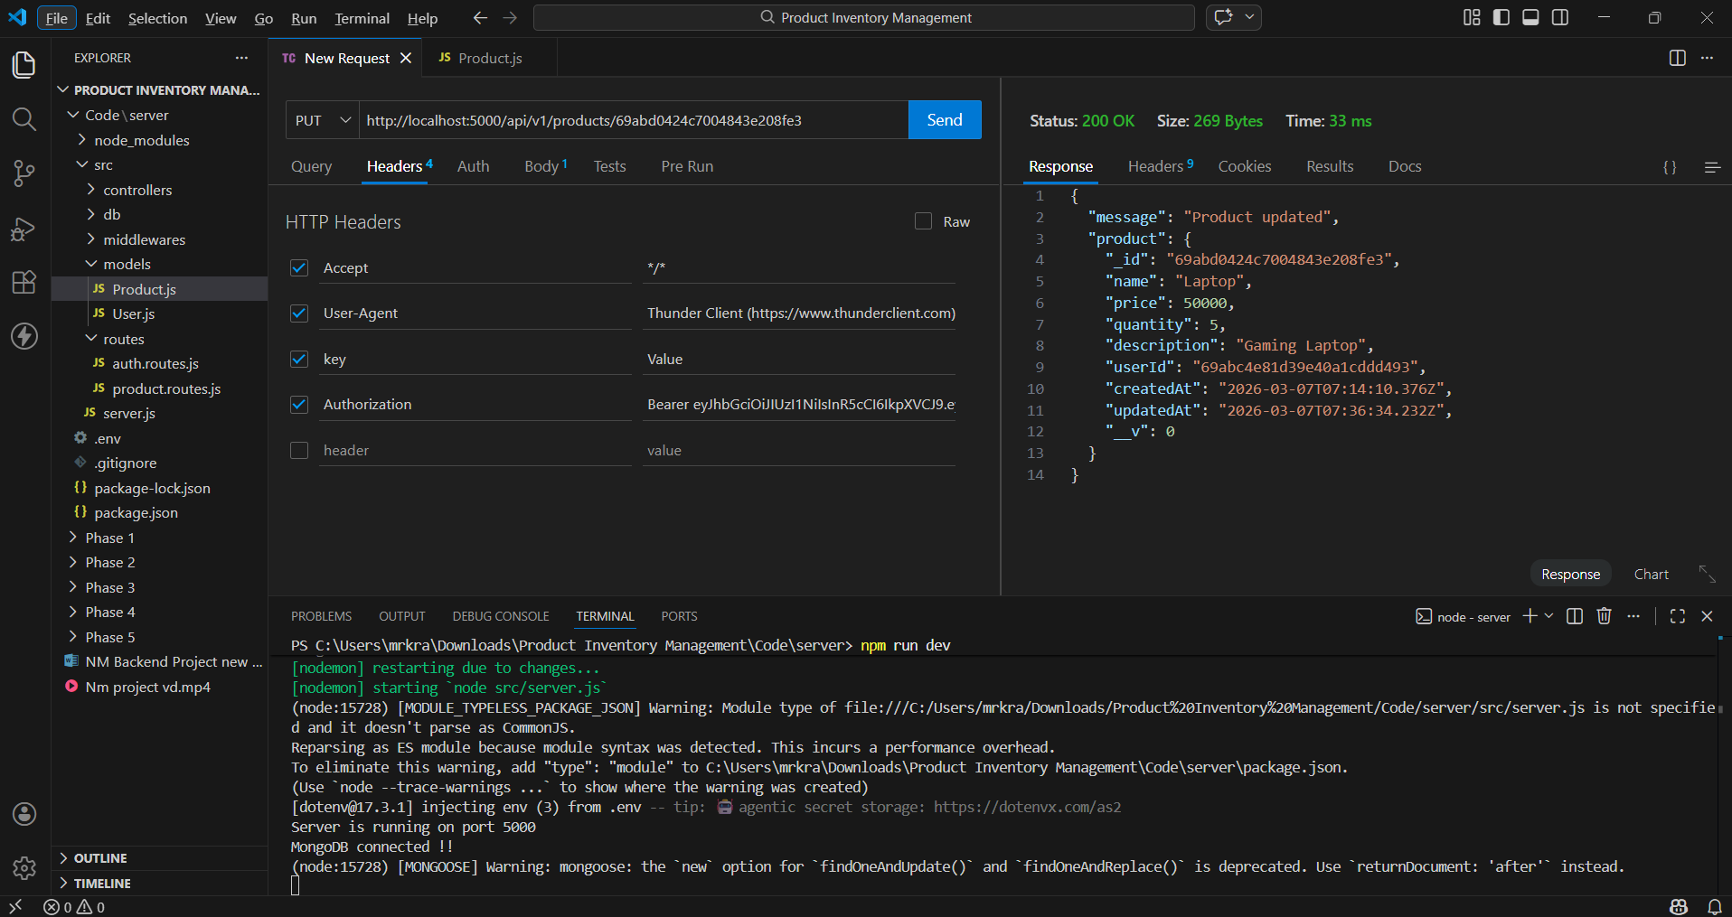

Delete Product API
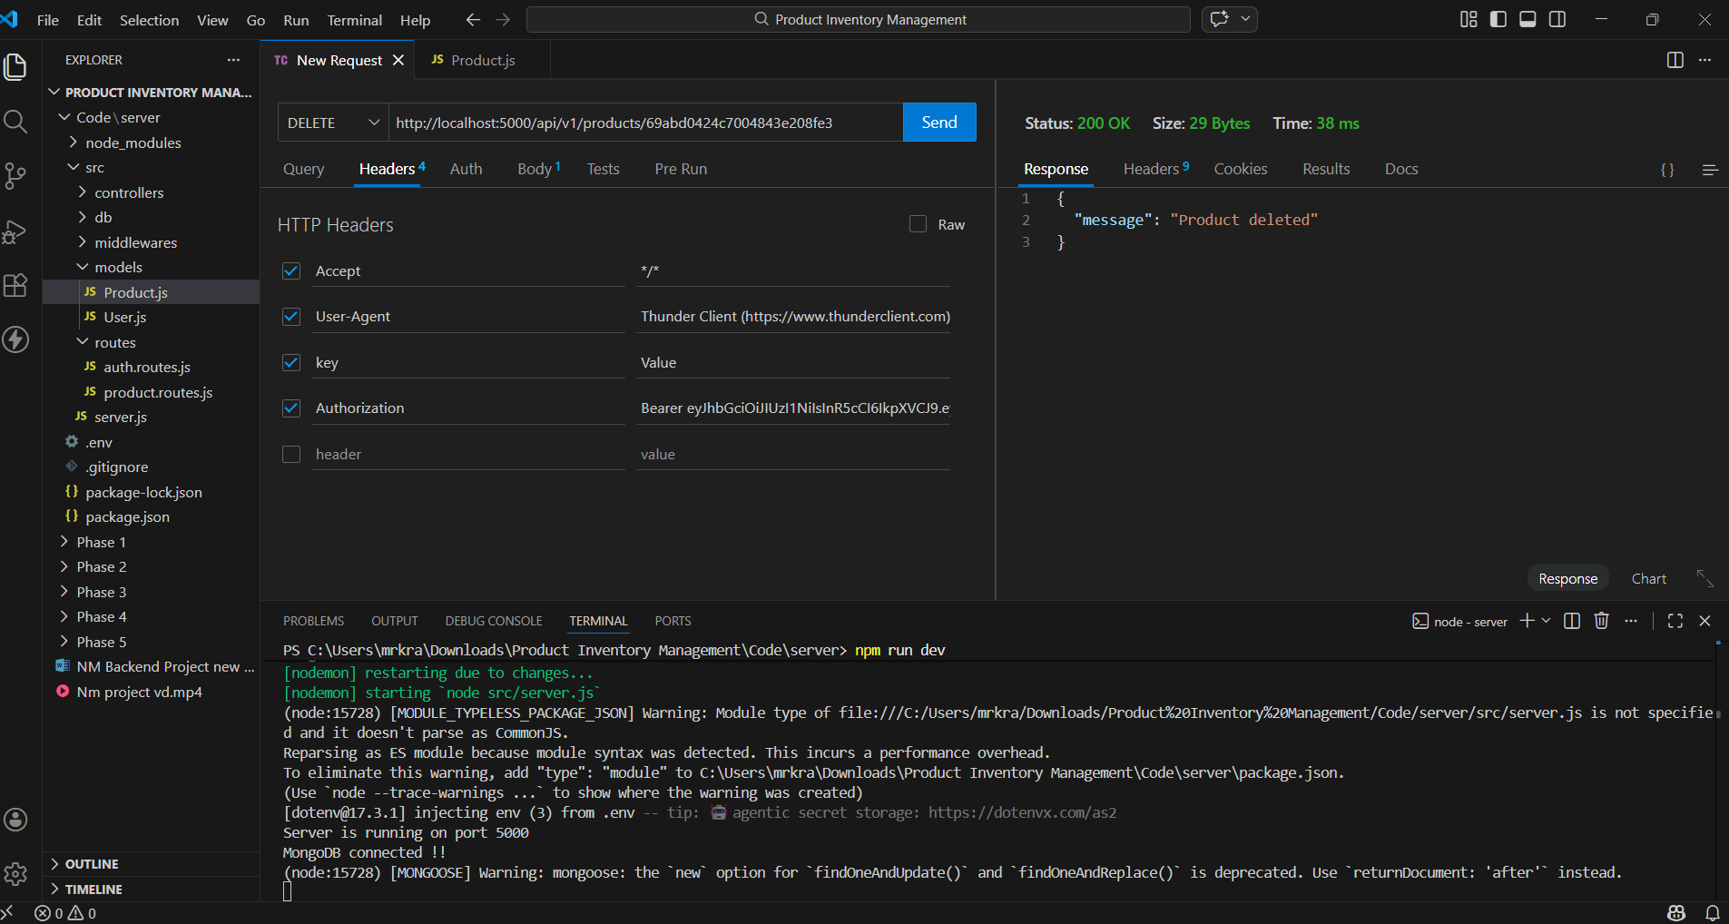

MongoDB Products Collection
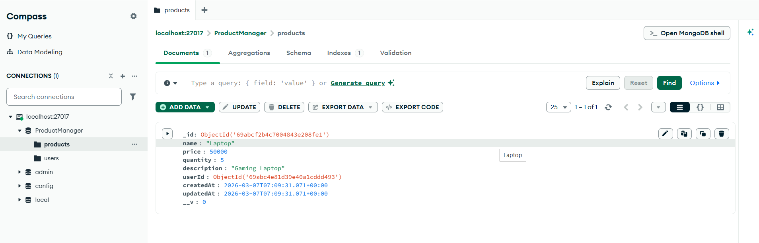

MongoDB Users Collection
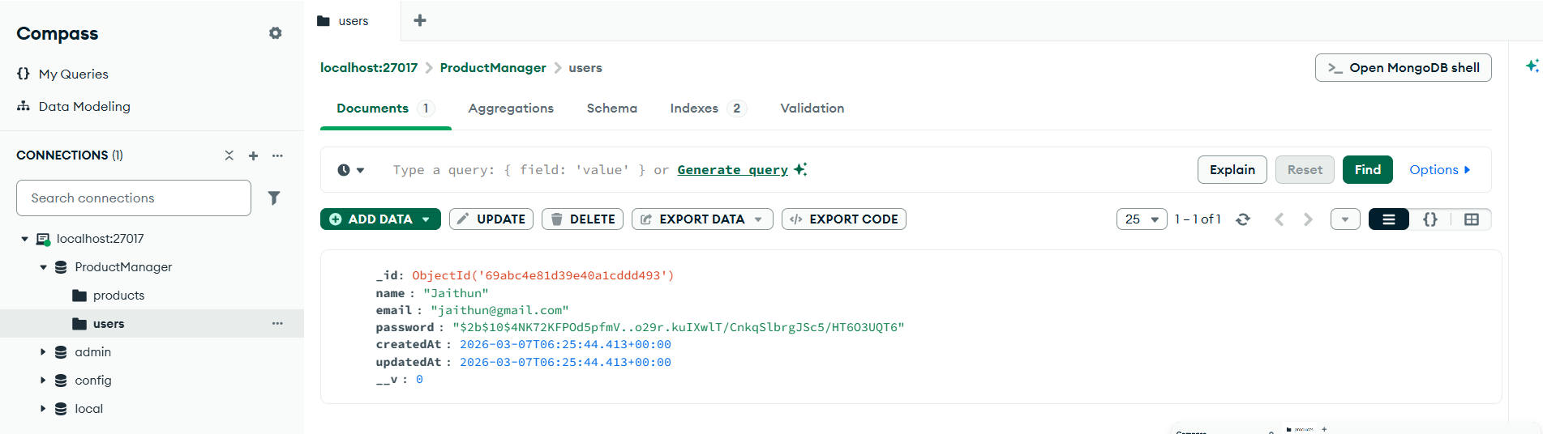

8. Results and Discussion
The system successfully performs all required operations including user authentication and product inventory management. MongoDB stores all records securely and the API responds with appropriate status codes. The testing confirms that the backend system works as expected.
The system successfully performs all required operations including user authentication and product inventory management. MongoDB stores all records securely and the API responds with appropriate status codes. The testing confirms that the backend system works as expected.
The system successfully performs all required operations including user authentication and product inventory management. MongoDB stores all records securely and the API responds with appropriate status codes. The testing confirms that the backend system works as expected.
The system successfully performs all required operations including user authentication and product inventory management. MongoDB stores all records securely and the API responds with appropriate status codes. The testing confirms that the backend system works as expected.
The system successfully performs all required operations including user authentication and product inventory management. MongoDB stores all records securely and the API responds with appropriate status codes. The testing confirms that the backend system works as expected.
The system successfully performs all required operations including user authentication and product inventory management. MongoDB stores all records securely and the API responds with appropriate status codes. The testing confirms that the backend system works as expected.

9. Conclusion
The Product Inventory Management System demonstrates the implementation of a modern backend architecture using Node.js, Express.js, and MongoDB. The project highlights secure authentication, structured API design, and efficient database interaction.
The Product Inventory Management System demonstrates the implementation of a modern backend architecture using Node.js, Express.js, and MongoDB. The project highlights secure authentication, structured API design, and efficient database interaction.
The Product Inventory Management System demonstrates the implementation of a modern backend architecture using Node.js, Express.js, and MongoDB. The project highlights secure authentication, structured API design, and efficient database interaction.
The Product Inventory Management System demonstrates the implementation of a modern backend architecture using Node.js, Express.js, and MongoDB. The project highlights secure authentication, structured API design, and efficient database interaction.
The Product Inventory Management System demonstrates the implementation of a modern backend architecture using Node.js, Express.js, and MongoDB. The project highlights secure authentication, structured API design, and efficient database interaction.
The Product Inventory Management System demonstrates the implementation of a modern backend architecture using Node.js, Express.js, and MongoDB. The project highlights secure authentication, structured API design, and efficient database interaction.

10. Future Enhancements
Future improvements may include developing a frontend interface, adding advanced search functionality, implementing role-based access control, and deploying the application to a cloud platform.
Future improvements may include developing a frontend interface, adding advanced search functionality, implementing role-based access control, and deploying the application to a cloud platform.
Future improvements may include developing a frontend interface, adding advanced search functionality, implementing role-based access control, and deploying the application to a cloud platform.
Future improvements may include developing a frontend interface, adding advanced search functionality, implementing role-based access control, and deploying the application to a cloud platform.
Future improvements may include developing a frontend interface, adding advanced search functionality, implementing role-based access control, and deploying the application to a cloud platform.
Future improvements may include developing a frontend interface, adding advanced search functionality, implementing role-based access control, and deploying the application to a cloud platform.

PROJECT OVERVIEW:NM project video.mp4

